What Is Saunders’ Research Onion?
The Research Onion (by Saunders, Lewis & Thornhill, 2019) is like a recipe for planning your research.
Each layer helps you make a decision — from your way of thinking about knowledge to how you’ll collect and analyze data.Just like peeling an onion you move from the outer layer to the inner layer — from broad ideas to specific actions.
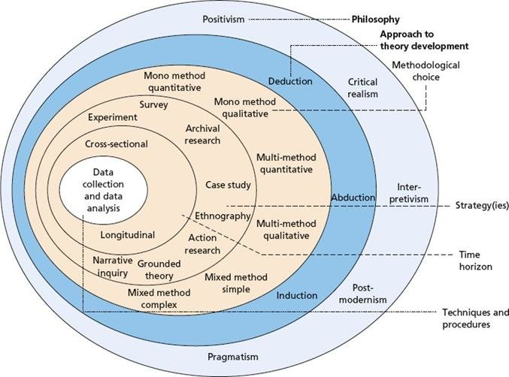
Layer 1 – Research Philosophy (Your Belief About Knowledge)
This is about how you see the world and what you believe “truth” is.
Philosophy | Simple Meaning | Example
Positivism | Facts and numbers explain the world. Research should be objective.  Factual, verifiable, impartial, and measurable. | A survey to test if social media use increases anxiety levels.
Interpretivism | People’s experiences and meanings are important.  Relies on individual interpretation, emotions, and personal experience | Interviewing teachers to understand how they feel about online learning.
Realism | There is one reality, but people see it differently. | Studying how customers and employees view the same company policy differently.
Pragmatism | The best method is the one that helps answer the question — mix methods if needed.  emphasizes the practical consequences and usefulness of ideas over abstract or theoretical concepts. | Using both surveys and interviews to study student motivation.
Think of this as your mindset before you start collecting data.

Layer 2 – Research Approach (How You Build or Test Theory)
This is how you move between theory and data.
Approach | Simple Meaning | Example
Deductive | Start with a theory → test it with data. | “Students with higher attendance have better grades.” Then collect data to test it.  H_{0 –} Students’ attendance and grades are not related to each other. (negative)  H₂ ₋ Students’ attendance and grades are related to each other (something there)
Inductive | Start with data → build a theory from it. | Interview students first, then develop a theory about attendance and grades.

Deductive = testing something you already believe; Inductive = discovering something new.

Layer 3 – Research Strategy (Your Plan or Blueprint)
This is the overall plan for how you will collect and study your data.
Strategy | What It Means | Example
Survey | Collect data using questionnaires. | 100 students answer questions about stress levels.
Case Study | Study one situation in depth. | Studying how one university handled online exams.
Experiment | Test cause and effect. | Testing if music improves memory.
Action Research | Work with others to solve a real problem. | Teachers and researchers improving classroom engagement together.
Grounded Theory | Build a theory directly from data. | Interview employees to develop a theory about job satisfaction.
Ethnography | Observe people in their real environment. | Observing gamers to study online behavior.
This is like choosing your research “game plan.”

Layer 4 – Methodological Choice (Quantitative, Qualitative, or Both?)
This layer decides what kind of data you will collect.
Choice | What It Means | Example
Quantitative | Numbers, statistics, measurable facts. | “70% of students use online learning tools daily.”
Qualitative | Opinions, meanings, and experiences. | “Students feel online learning reduces social contact.”
Mixed Methods | Use both types together. | Survey (quantitative) + interviews (qualitative).
Choose quantitative when you want to measure; qualitative when you want to understand.

Layer 5 – Time Horizon (When You Collect Your Data)
This refers to the time period covered by your research.
Type | Meaning | Example
Cross-Sectional | Data collected at one single time. | One-time survey of 200 customers in 2025.
Longitudinal | Data collected over a long period. | Studying how customers’ satisfaction changes over 3 years.
Cross-sectional = snapshot; Longitudinal = movie over time.

Layer 6 – Data Collection & Analysis (What You Actually Do)
This is the core of your methodology — how you collect and analyze data.
Stage | Description | Example
Data Collection | How you get the data. | Surveys, interviews, experiments, documents.
Sampling | Who or what you study. | 100 employees from 3 companies.
Data Analysis | How you make sense of it. | Statistical tests in SPSS or coding themes in NVivo.
Validity & Reliability | Making sure your results are accurate and consistent. | Pilot testing, cross-checking, triangulation.
This is where you “do” the research.

Example: Applying the Research Onion
Topic: “Impact of Remote Work on Employee Productivity.”
Layer | Choice | Explanation
Philosophy | Pragmatism | Combines numbers (productivity) and opinions (feelings).
Approach | Deductive | Tests if remote work increases productivity.
Strategy | Survey + Case Study | Collect survey data and study one company closely.
Methodological Choice | Mixed Methods | Uses both quantitative and qualitative approaches.
Time Horizon | Cross-Sectional | One-time data collection in 2025.
Data Collection & Analysis | Questionnaire + Interviews | Analyze using Excel for numbers and NVivo for themes.

In Simple Terms
- The outer layers = how you think about research.
- The middle layers = how you plan it.
- The inner layers = how you do it.

Key Reference
Saunders, M., Lewis, P., & Thornhill, A. (2019). Research Methods for Business Students (8th ed.). Pearson Education.

